|  |  |
| --- | --- |
| C:\Users\conyenakie\Desktop\West African Map.png | **WaterAid Senegal Visitors’ Welcome Pack** |

|  |  |
| --- | --- |
| **Scope** | **Regional People Management Framework** |
| **Introduction** | The nature of WaterAid’s work necessitates working in volatile and sometimes violent environments. At times this presents a threat to the security and well-being of our staff; an issue the organisation takes very seriously.  A Country Welcome Pack provides staff and visitors with a broad overview of the environment in which they are working or travelling to including essential security information good to know prior to visiting. It describes other factors that may not be included in a security plan such as currency information, cultural norms, local considerations, sensitivities, etc. |
| **Purpose** | The aim of this document is to inform short-term visitors of useful information that is important for their visit. Your welcome pack should:   * Provide a brief summary of the country including safety and security * Provide information on cultural practices * Provide information regarding airports and accommodation * Provide useful hints and tips regarding dress, communications, electricity, currency, eating out, getting around, health and climate. * Contain a short declaration to be signed by the visitor after the In-Country security briefing, whereby acknowledging that s/he is informed and understand the risks (informed consent). * To satisfy one of the requirements of WA’s duty of care.   Preferably visitors should be able to access this – or receive by mail – prior to departing for your country as a Pre-Departure brief. |
| **First Published** | **January 2018** |
| **First Revision** |  |

**Global Security Framework**

This document is part of the Global Security Framework that consists of policies, a toolkit, procedures and a template pack, as illustrated below.

Policies

Toolkit

Procedures

Templates

Global Security Policy

Emergency Number

Crisis Management

Medical Response & Evacuation

Repatriation of Deceased

Psychosocial Care

Incident Reporting

Kidnap

Security Handbook

Essential Security Package

Security Plan

Welcome Pack

‘RED’ Form

Contingency Plans

Risk Assessment

Context Analysis

Incident Report Form

International & Domestic Travel

Welcome to Senegal/Bienvenue au Senegal

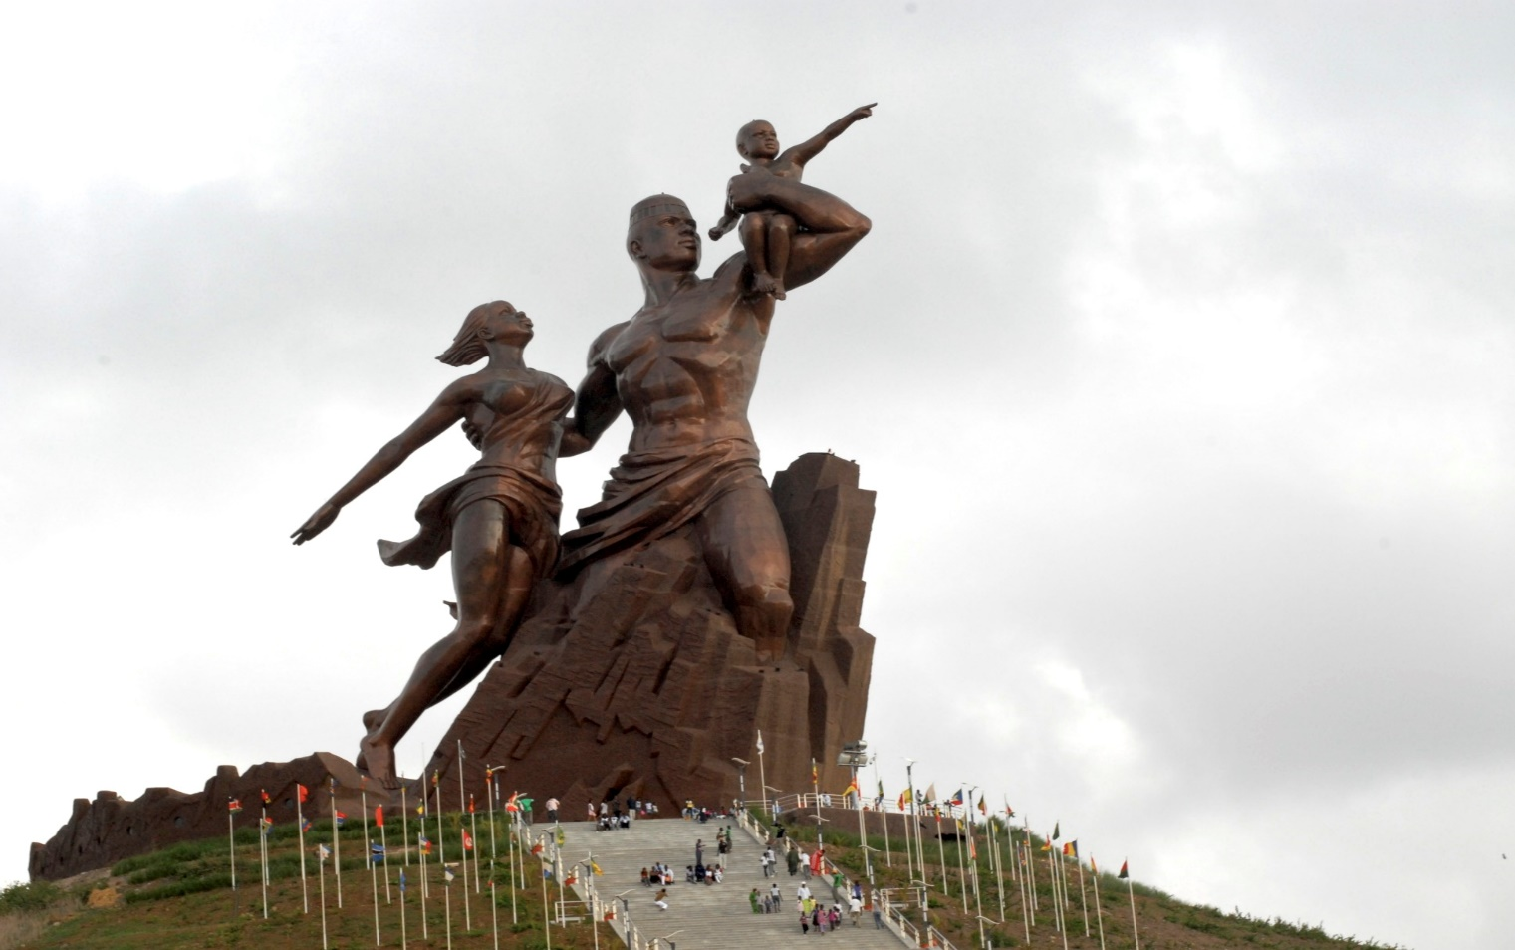

**Introduction**

WaterAid Senegal is often hosting international visitors from member offices, donors and supporters.

The aim of this Welcome Pack is to inform short-term visitors of useful information that is important for their visit. It is updated regularly to reflect current security situation in Senegal, and will also provide some useful information that visitors should know before starting their journey. The document serves as a Pre-Departure Brief and will be supplemented by a verbal security briefing upon arrival to Senegal.

**Country Summary**

Senegal has belonged to the West African Empire of Mali, Ghana, and Tekrur. Wolof people reported that ‘Senegal’ is derived from ***Sunu gaal****,* meaning “our boat”. That’s why guests are always welcome.

The river Senegal flows in the North and East parts with Mauritania and Mali as border countries.

Senegal became independent in 1960 after three centuries under French colonial rule. The capital city, Dakar spreads on the Cape Verde peninsula which is the remotest place towards West of Africa.

Though predominantly a Muslim country, Senegal is a tolerant and secular State where people have been living together peacefully for several generations and have intermingled to some extent. Islam is a potential unifying factor. Wolof is the main language. The promotion and development of education and increased economic opportunities have changed the traditional social organisation focusing on kinship and solidarity. Most people however value traditional values of *Kersa* (respect for others) and *Tegin* (good manners). For almost all the twelve ethnical groups in the country, *Teranga* (hospitality) is a daily used word.

Senegal counts an estimated population 13.6 million people including 49.9% males and 50.1% females. The population is young –an average of 22 years and half are 18.7 years old. 54.8% people live in rural as opposed to 45.2% in urban settings. There is an uneven geographic distribution of this population in the regions and Local Governments with Dakar the most densely populated area with 3 million people as compared to Kédougou with 9 inhabitants per sq[1].

Senegal is divided into 14 administrative regions, each headed by a governor appointed by and responsible to the President. The decentralization law, which came into force in January 1997, devotes significant powers to regional assemblies. However, despite its adoption, the country's leadership has remained highly centralized, including resource management and water.

**Entry Requirements & accommodation information**

* **Passport &** **Visa: West Africa nationals are not subject to entry visa to Senegal. Many countries are visa free but there are still some nationals of other countries that should apply for an entry visa to Senegal**. Please check your own visa requirements before travel. Visas may be obtained online or at Senegalese embassies and consulates. Vaccination against yellow fever is also required before entry. Travellers may obtain additional information at the nearest overseas Senegalese embassy or consulate.
* **Climate:** The climate is tropical and dry with two seasons: the dry season from November to June with continental trade winds, with temperatures between 22°C and 30°C, with signiificant variations between the coastline and the interior. The raining season is July to October with a peak in August-September).
* **Transport from the airport and back to the airport:** Your transportation from the airport to the Hotel will be provided either by WARO Driver or the hotel shuttle.
* **Telecommunications:** The country code for Senegal is (221) for international communications. For national communications, you have the choice between three operators Orange Senegal, Expresso, Tigo.
* **Hotel Rooms:** Hotel rooms are basic but clean in nature, with air conditioner and hot & cold water. Laundry service is usually available. A TV set is also available with international channels such as CNN, BBC, France24, and TV5. Senegal operates a 220 volts AC electricity system. Wall sockets use a 2-pin system and visitors from English speaking countries may need adapters. You are advised to bring a universal plug/socket adaptor if you would like to use electrical appliances and computers from your home country in Senegal.
* **Accommodation and meeting:** You will stay atONOMO Hôtel and the meeting will be held at WARO office. The hotel is located in the road of the first Airport LSS of Yoff and is 58km away from the new airport AIBD and 12km away from the city centre.

To know more about the hotel, please visit: <https://www.onomohotel.com/fr/hotel/1/onomo->hotel-dakar-airport.

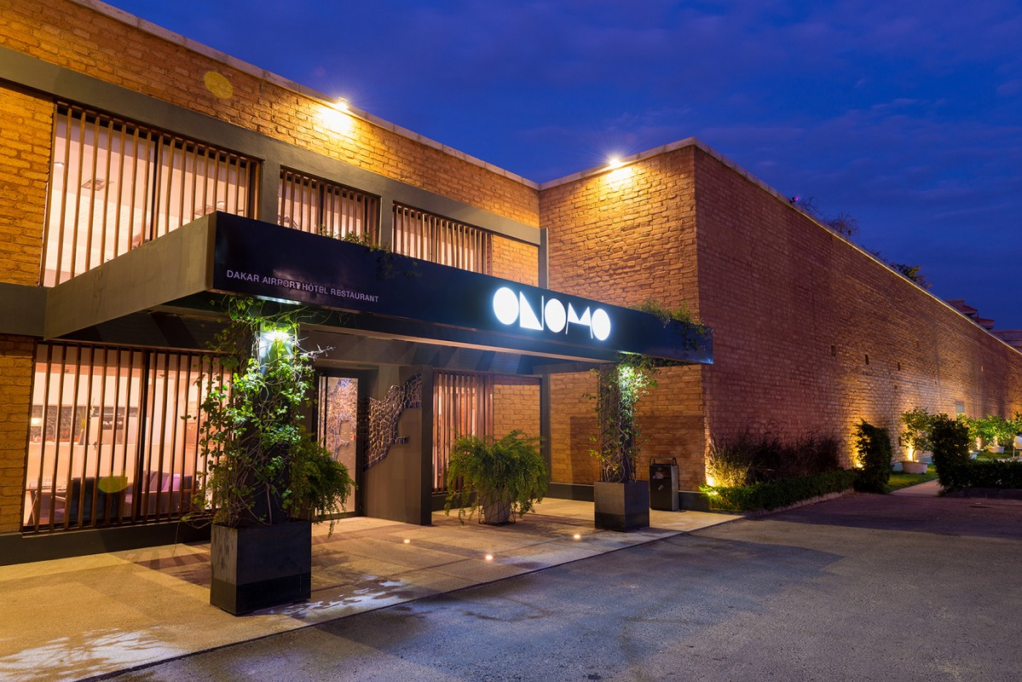

* **Currency and banking:** The currency used in Senegal is CFA. 1 Euro (EUR) = 655.957 CFA Franc BCEAO (X0F). If you want to buy currency, you can do so at currency exchange offices or at banks. Avoid buying currency with individuals sitting in front of banks. Though credit cards (Visa, Mastercards) can be used at major hotels, please have a small bank notes with you to cover for petty expenses.
* **Health:** Before your departure, check with your doctor and take out a contract with an insurance company to cover your medical expenses and repatriation.

It is advised to be immunized against yellow fever and follow an anti-malaria treatment.

Drink only bottled or sterilized water

* **Security:** Overall, Senegal is a safe place but in Dakar, beware the pickpockets. At nights, avoid being too far from your hotels or else, always stay in a group.

**Some tourist attractions in Dakar**

http://dp.mariottini.free.fr/images-titre/fl_actu.gif You can easily walk through the city centre lying between the Cathedral and Independence Square. This political hub of the city has embassies, the National Assembly, Soweto Square, and downward the Boulevard de la République is the Presidential Palace not far at all from the cathedral (1929) and IFAN (Fundamental Institute of Black Africa) an ancient museum of African art (1931).

http://dp.mariottini.free.fr/images-titre/fl_actu.gifIt is found under the arcades of the Independence Square headquarters of banks, airlines and travel agencies. From the Independence Square, one can go down to the port, passing the beautiful City Hall to reach the big square of Casablanca where luxury will be yours to admire the very old train station for trains connecting Dakar to Bamako. From this station, one can access the port of Dakar and at the entrance to the wharf of Gorée Island.  
Gorée is a small island 900 meters / 3000 feet in length and 350 meters. Gorée is a tourist destination known as the location of the House of Slaves.

Markets: the four most active ones are Sandaga and Kermel found in city centre. Tilene in the Medina and Soumbedioune on the ridge are more off-centre.

http://dp.mariottini.free.fr/images-titre/fl_actu.gif The Sandaga market offers beautiful fabrics apart from the known stalls for meat, fish, fruit and vegetables.  
http://dp.mariottini.free.fr/images-titre/fl_actu.gifKermel market near the Independence Square is generally an attraction site of tourists.  
http://dp.mariottini.free.fr/images-titre/fl_actu.gifTilene market is the most authentic yet to be avoided on Fridays when big prayer is said with a packed crowd making the area more or less unsafe.  
http://dp.mariottini.free.fr/images-titre/fl_actu.gifSoumbedioune is a large village created in 1961 where hundreds artisans offer visitors some beautiful African crafts including crocodile leather, printed cloths, statutes and masks carved in ebony, etc.

Caution Call! In Dakar, people can come alongside in the street trying either to rob your money or else tell you stories to distract your attention. So please, always kindly say “No Thank you” to those people. Smile and politeness are still popular in Senegal.

**Key Contacts**

|  |  |  |
| --- | --- | --- |
| **WaterAid West Africa Regional Office WARO Senegal** | | |
| Villa n° 22 Cité Sonatel Prestige, Ouest Foire, Dakar-Sénégal | | |
| Tel: (221) 33 859 08 30 | | |
|  | | |
| Mariame DEM | Regional Director | 221 77 740 17 43 |
| Oumar NDIAYE | Regional Funding Manager | 221 77 099 80 69 |
| Tabila NDOUR | Finance Manager / Security Focal Point | 221 77 099 88 53 |
| Maimouna TALL | Regional Support Officer | 221 77 333 62 03 |
| Fatma DIOP | IT Officer | 221 77 542 19 32 |
| Malick SOW | Driver | 221 77 884 29 98 |
| Magatte SALL | Admin & Finance Intern | 221 77 543 07 37 |
| **Police – Gendarmerie – Fire brigade** | | |
| Gendarmerie Foire | | (221) 33 827 54 65 |
| Police | | (221) 33 820 46 96 |
| Fire brigade | | 18 |
| **Medical Emergency** | | |
| Clinique Medic’ Kane | 33 859 49 49 | |
| SOS Medecins | 33 889 15 15 | |
| Suma Assistance | 33 865 18 18 | |
|  | | |

1.